Process Management:

PS
Option Meaning
-e Select all processes
-f Full-format listing
a Show processes associated with terminals from all users
u User-oriented format
x Include processes without a controlling terminal

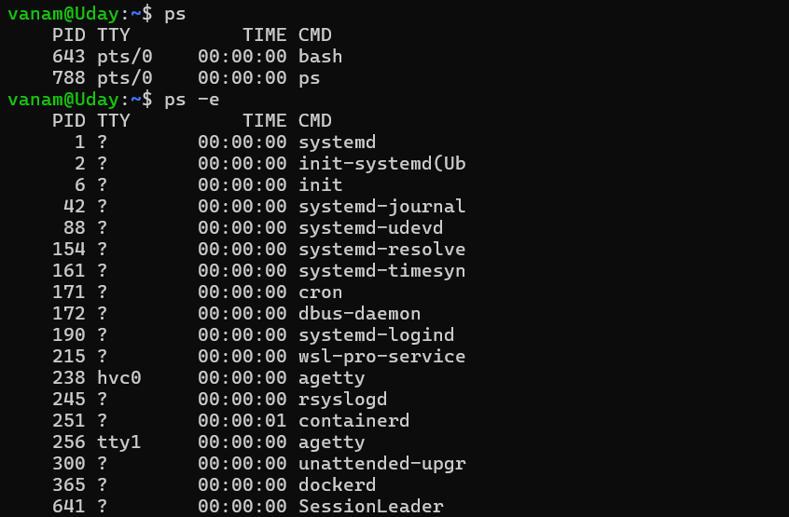

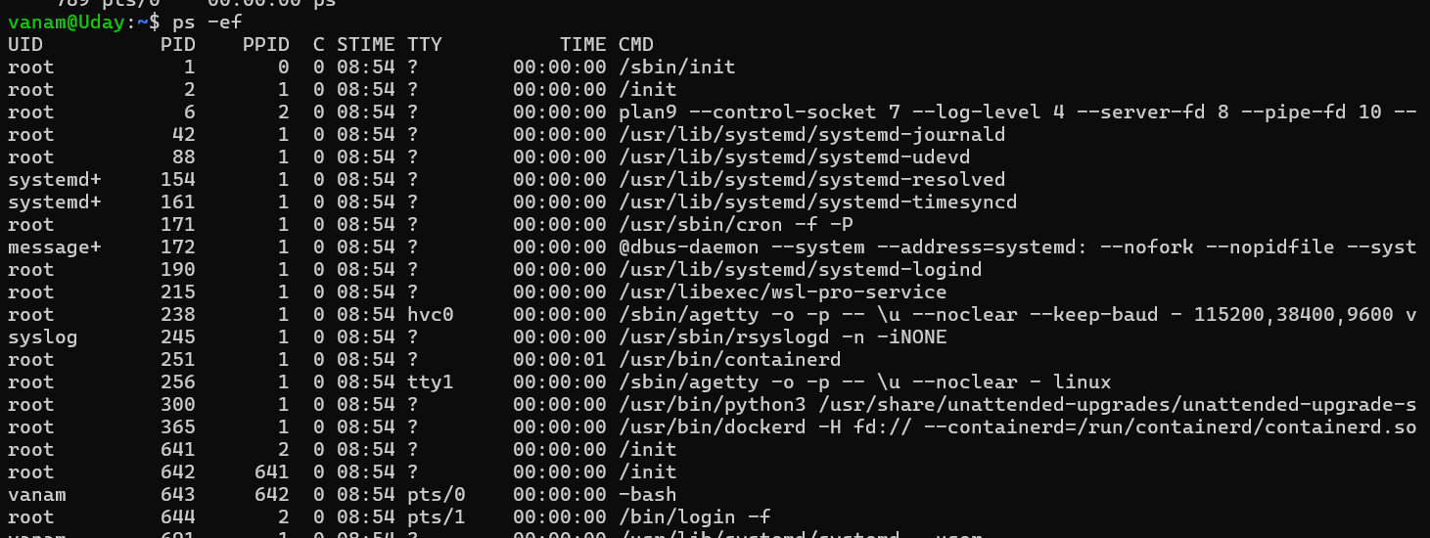

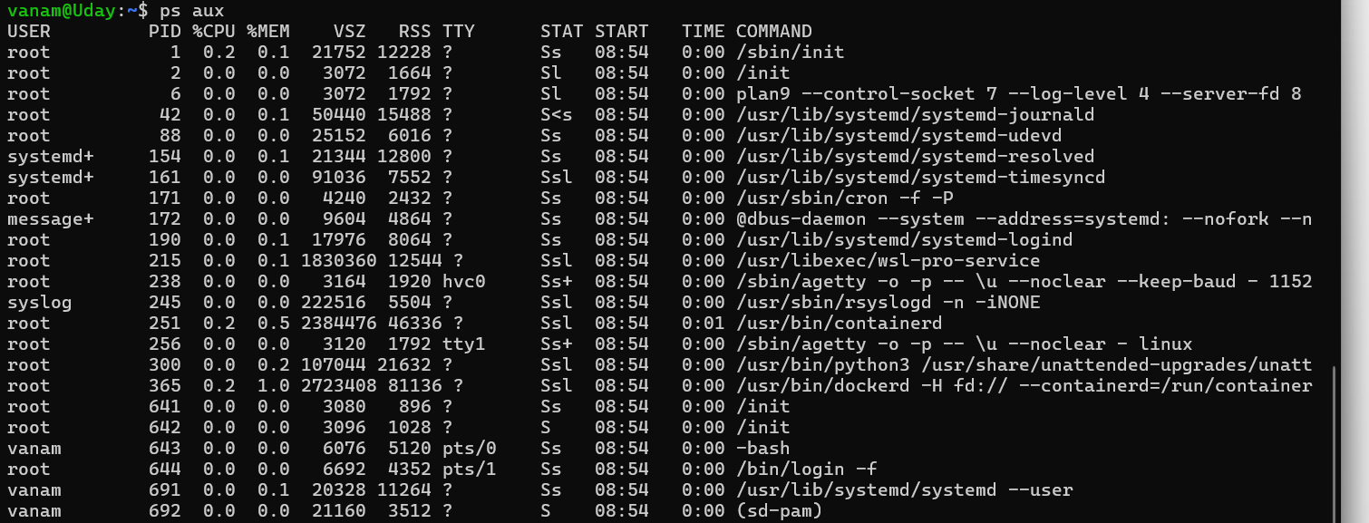

Top

Key | Action
P | Sort by CPU usage
M | Sort by memory usage
1 | Toggle individual CPU-core statistics
k | Request to terminate a process by PID
q | Quit

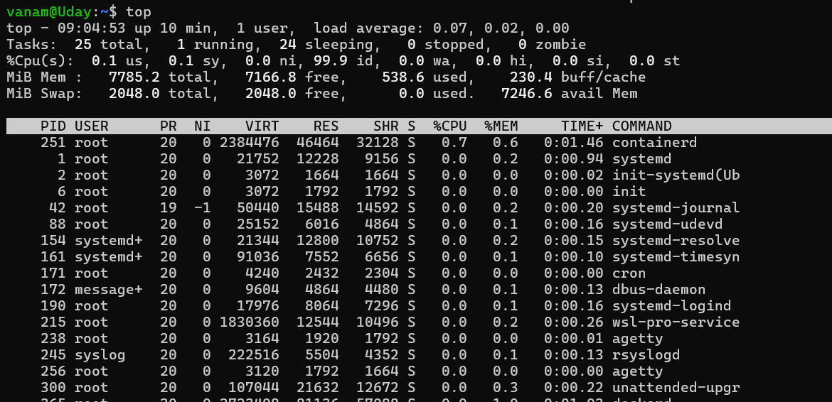

P
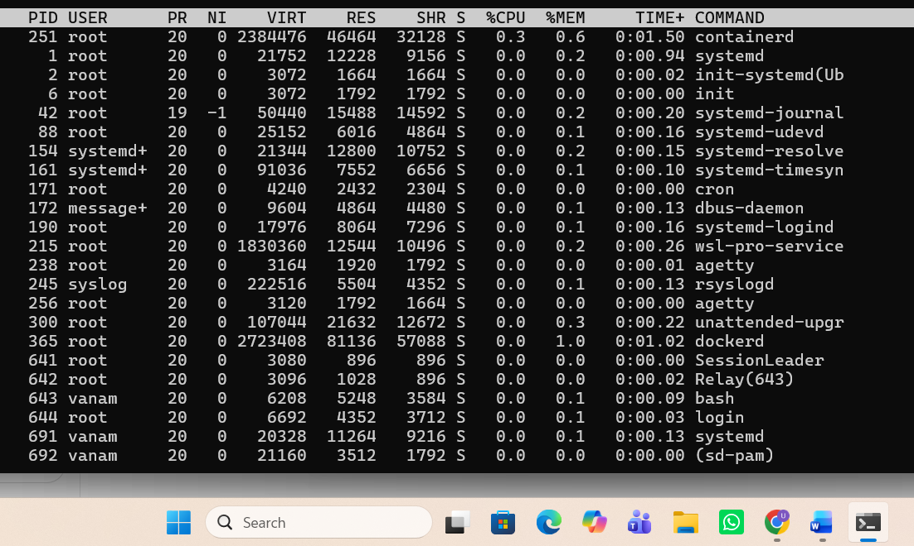

M
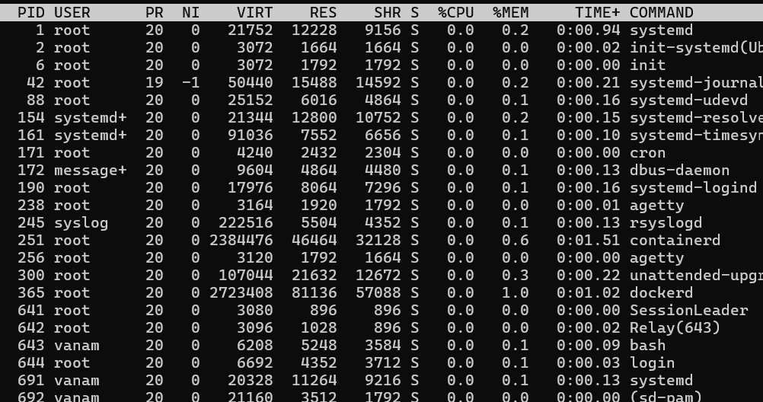

Creating a Process
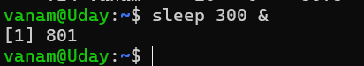



Killing a Process


df — Check filesystem disk space

Option | Meaning
-h | Human-readable sizes, such as MB and GB
-T | Display filesystem type
-i | Display inode usage instead of block usage

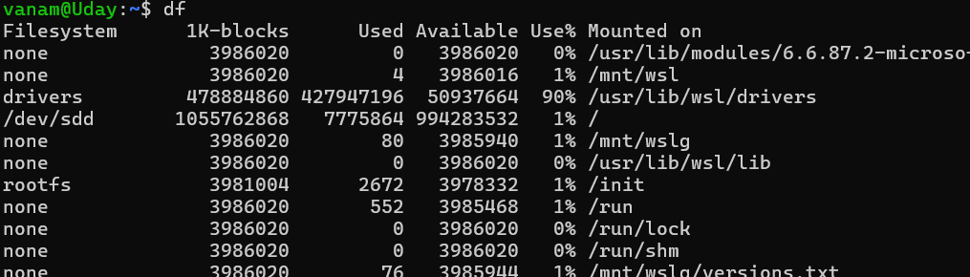
H

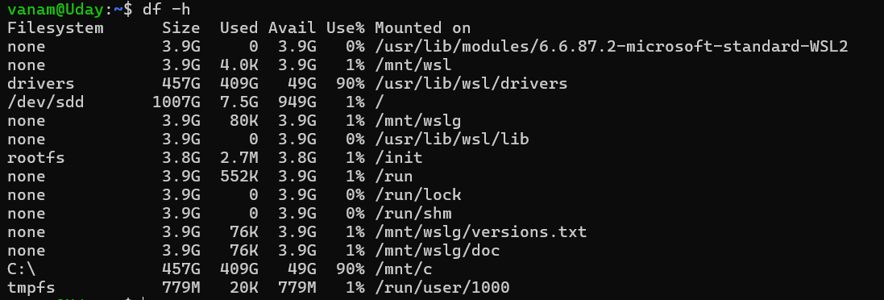

T
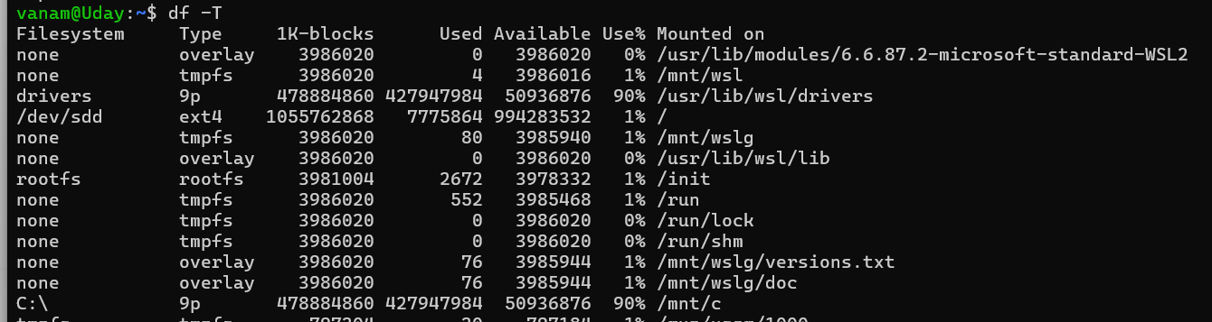

du — Check directory and file sizes





free — Check memory usage

Option | Meaning
-h | Human-readable units
-m | Display values in MiB
-g | Display values in GiB
-s 2 | Repeat the display every 2 seconds

H
M
In mb

uname — Get kernel and system information
Option | Meaning
-a | Display all available system information
-r | Kernel release
-m | Machine hardware architecture
-s | Kernel name
-n | Network hostname

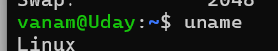
R
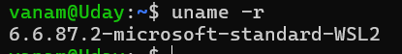
M

ip — Inspect network interfaces and addresses

Option or subcommand | Meaning
addr | Show IP addresses and interfaces
-br | Brief, compact output
route | Display routing information
link | Display network-interface information

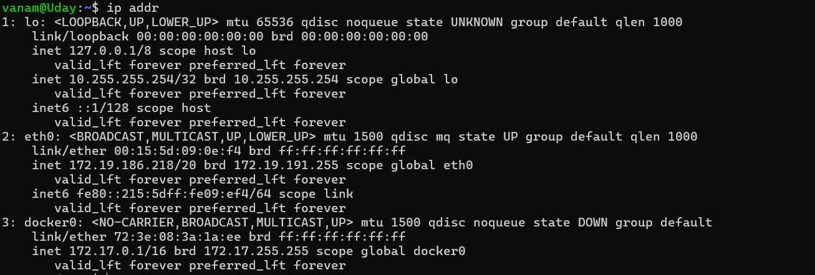
Addr
Curl
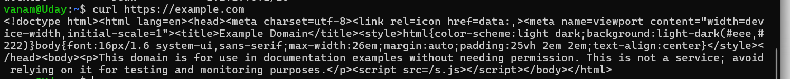
jobs — Inspect background jobs
